Information Retrieval
4 April 2019

Name: Surname: Matricola:

Ex 1 [points 5+5+5]
- Define what is a Bloom filter, the operations supported, and show the formula of the error rate (as a function of the space and number of keys) and prove its correctness.
- Show how the Jaccard similarity between two sets A and B can be estimated via min-hashing, as a function of the number of extracted minima.
- Define Link Probability and Commonness as they are used by entity annotators, like TagMe.

Ex 2 [points 4+3]
Given the three strings s1 = “asta”, s2 = “balla”, and s3 = “basta”, show the compression
- by gzip with window size w=5 chars when concatenated as s1 s2 s3,
- by Zdelta applied to the set of those strings deriving their concatenation order via the approach based on a weighted graph where the cost of edges is estimated via gzip. (Hint: refer to “compression of a group of files” by Zdelta)

Ex 3 [points 4+4]
Given the graph

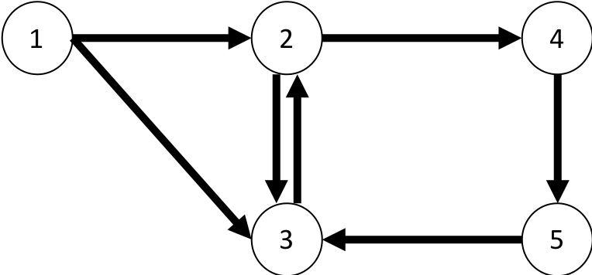

- Execute one step of the PageRank algorithm, assuming uniform teleportation step, alpha = ½ and uniform starting probability.
- Execute one step of the Personalized PageRank algorithm with respect to the node 1, assuming alpha = ½ and uniform starting probability.

